|  |
| --- |
| MIT and lincoln laboratory |
| Woodward and Generator Controller Modeling |
| Model Development and Unit Testing |
|  |
| **Kendall Nowocin** |
| **11/23/2015** |

This material is based upon work supported by the Assistant Secretary of Defense for Research and Engineering under Air Force Contract No. FA8721-05-C-0002 and/or FA8702-15-D-0001. Any opinions, findings, conclusions or recommendations expressed in this material are those of the author(s) and do not necessarily reflect the views of the Assistant Secretary of Defense for Research and Engineering.

© 2015 Massachusetts Institute of Technology.

Delivered to the US Government with Unlimited Rights, as defined in DFARS Part 252.227-7013 or 7014 (Feb 2014). Notwithstanding any copyright notice, U.S. Government rights in this work are defined by DFARS 252.227-7013 or DFARS 252.227-7014 as detailed above. Use of this work other than as specifically authorized by the U.S. Government may violate any copyrights that exist in this work.

|  |
| --- |
| This document outlines the secondary and primary controllers for a generator model and a small power system for unit tests. The tertiary controller is the user. Model development and unit test were performed to commission the Woodward generator controllers. |

Software:

The software/firmware is provided on an As-IS basis.

# Woodward with Modeled Primary Controllers and Prime Mover

## Library

Demonstration / system of elements

## 1.1 Description

There are three milestone files (v7, v8, and v9) and each model was built off of the previous milestone. There are basic elements of the model that will be highlighted in this document. Each milestone has been tested by opening and running it in Matlab R2011b (32 bit).

### 1.1.1 Top Level Model:

The highest level of the model has the time step, OPAL RT Artemis solver, and the subsystem’s Master and Console. The time step is set to 50 µs as the default, but can be adjusted faster or slower depending on fidelity and simulation resolution needed. The OPAL RT Artemis solver is a different solver than what Matlab defaults too. The Artemis solver has improvements over the basic solver, and there are paper references online that discuss its advantages. The Console subsystem can be related to the user interface when the model is running either in simulation or on the HIL Target. The Master subsystem can be related to the Plant, and occupies one core. If there is a Slave subsystem, then this occupies one core.

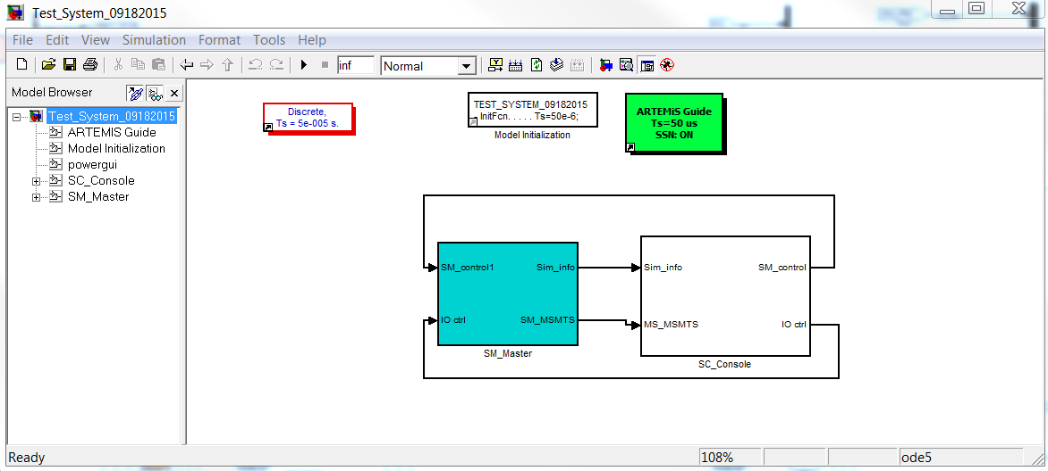

Figure 1: Top Level Model that shows the master (plants) and console (user interface and scope signals). The time step is 50µs, the green block is the OPAL RT ARTEMIS Solver. The SM_Master takes up a core on the target.

Example 1: There is a Console subsystem and Master subsystem. This is the minimum needed, the Master occupies a core, therefore only one core is needed / being used. The console runs on the targets internal core.

Example 2: There is a Console subsystem, Master subsystem, and 2 Slave subsystems. There are 3 cores (Master and 2 Slaves) out of the number of “x” available cores.

### 1.1.2 Master Subsystem:

The mapping of the I/O box to the appropriate component’s models is located in this subsystem. This includes digital inputs, digital outputs, analog inputs, and analog outputs, and any signal that would be connected to the physical world. The plant components (Grid, Relays, Load, and Generator) of the modeled system are included here. The generator includes a simulated primary control of governor and automatic voltage regulator, simulated prime mover of rated machine, and the choice of a secondary controller that is physical (i.e. Woodward EasyGen 3500) or simulated (internal model). The relays included are the Generator Circuit Breaker (GCB), Mains Circuit Breaker (MCB), and Load Circuit Breaker (LCB). These breakers operate independent of each other, and depending on the secondary controller configuration may operate via internal or physical external control.

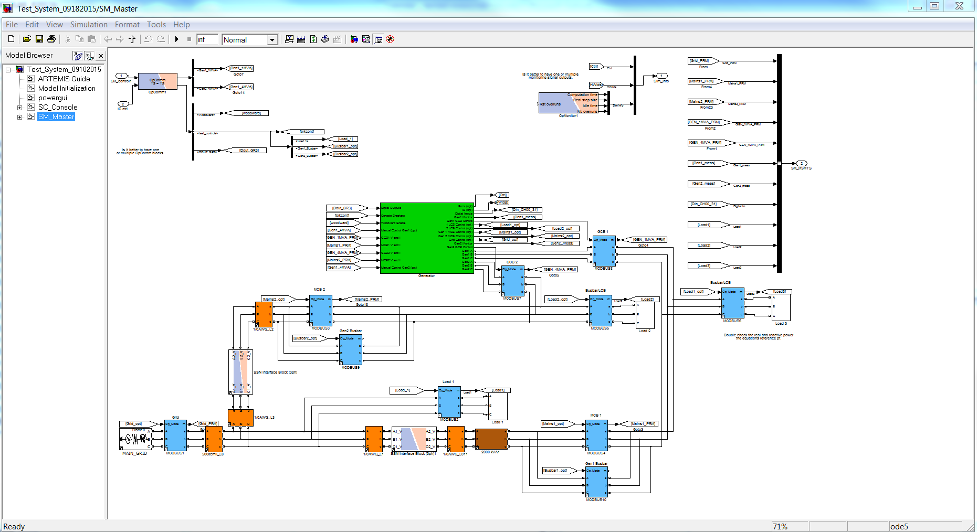

Figure 2: This is the model inside the Master subsystem. It includes relays in blue, 3 phase lines in orange, OPAL RT state space nodes (SSN) connectors in white with red and blue, and the generator connection and model in green. The top left bus is the signals from the console and the top right bus is signals sent to the console.

### 1.1.3 Console Subsystem:

The scoped signals and user interface controls are included here. The scopes have labels to correspond to the point that is being monitored. The digital switches and labeled constant blocks control the type of control (simulated or physical secondary controller, with or without digital I/O, with or without filtering of the analog biases, and with or without breaker control) the model is in.

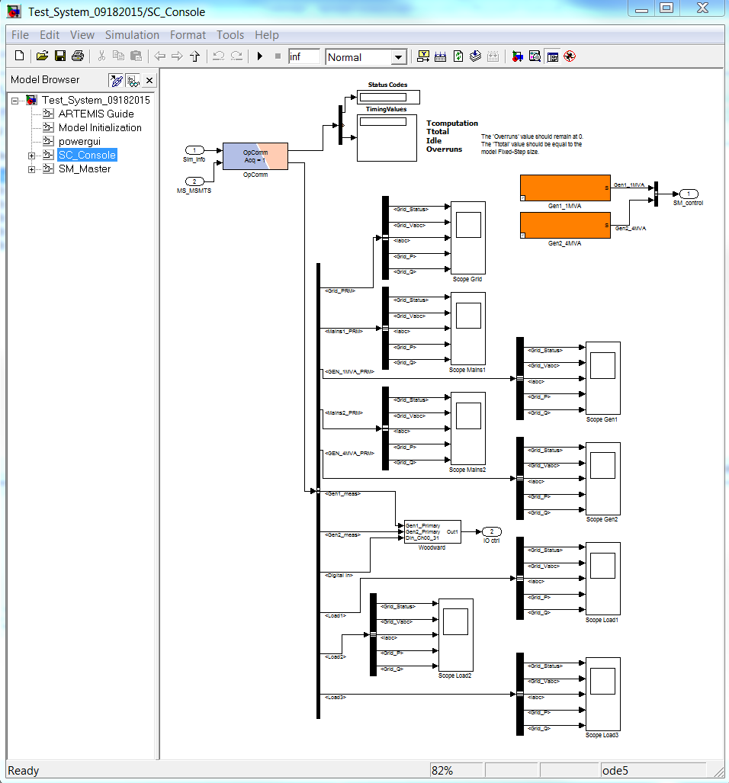

Figure 3: This is the model inside the Console subsystem. It includes the simulated secondary controller in orange for the 1 and 4 MVA generators, scopes for all the relays, and Woodward signals for test control and feedback.

## 1.2 Dialog Box and Parameters:

### 1.2.1 Console Subsystem:

#### 1.2.1.1 Woodward Secondary Controller (white colored subsystem)

The controls for simulated vs physical secondary controller, relays, scopes, and physical I/O are included. The constant “control mode” with the line label “Woodward” controls whether the physical device controller (control mode = 1) or the internal secondary controller (control mode = 0) signals are used for the inputs to the primary controller and prime mover. The area of constants that get multiplexed control the relays and what physical signals are passed to the simulated components. This is used to trouble shoot the system or walk through a particular sequence of events. The configuration of the console digital output switches is in the “16Din/16Dout Gr3” block. The scope for the primary controller includes the values (mechanical power (Pm), field voltage (Vf), terminal voltage (Vt), and rotor speed (w)). There is a reference signal and actual signal shown. In the case of Vt and w there is a bias signal shown in addition.

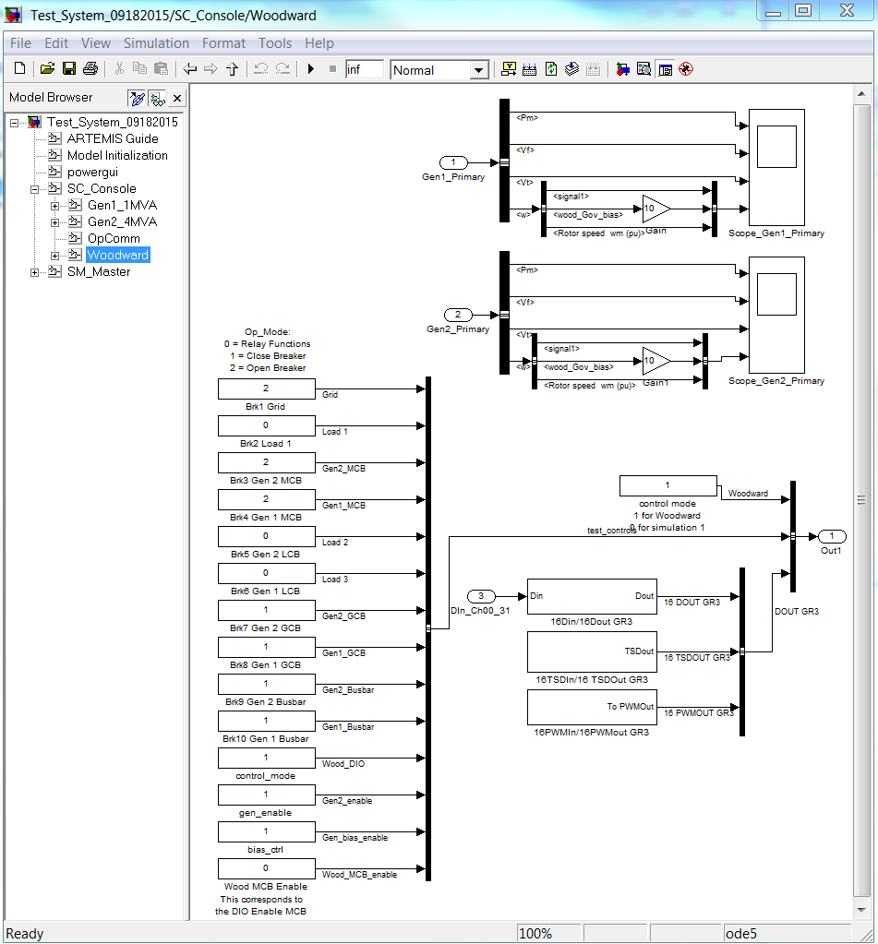

Figure 4: This is the console for the Woodward secondary controller. The scopes for the primary controller signals, digital input and output, and control of the modeled relays in the power system are located here.

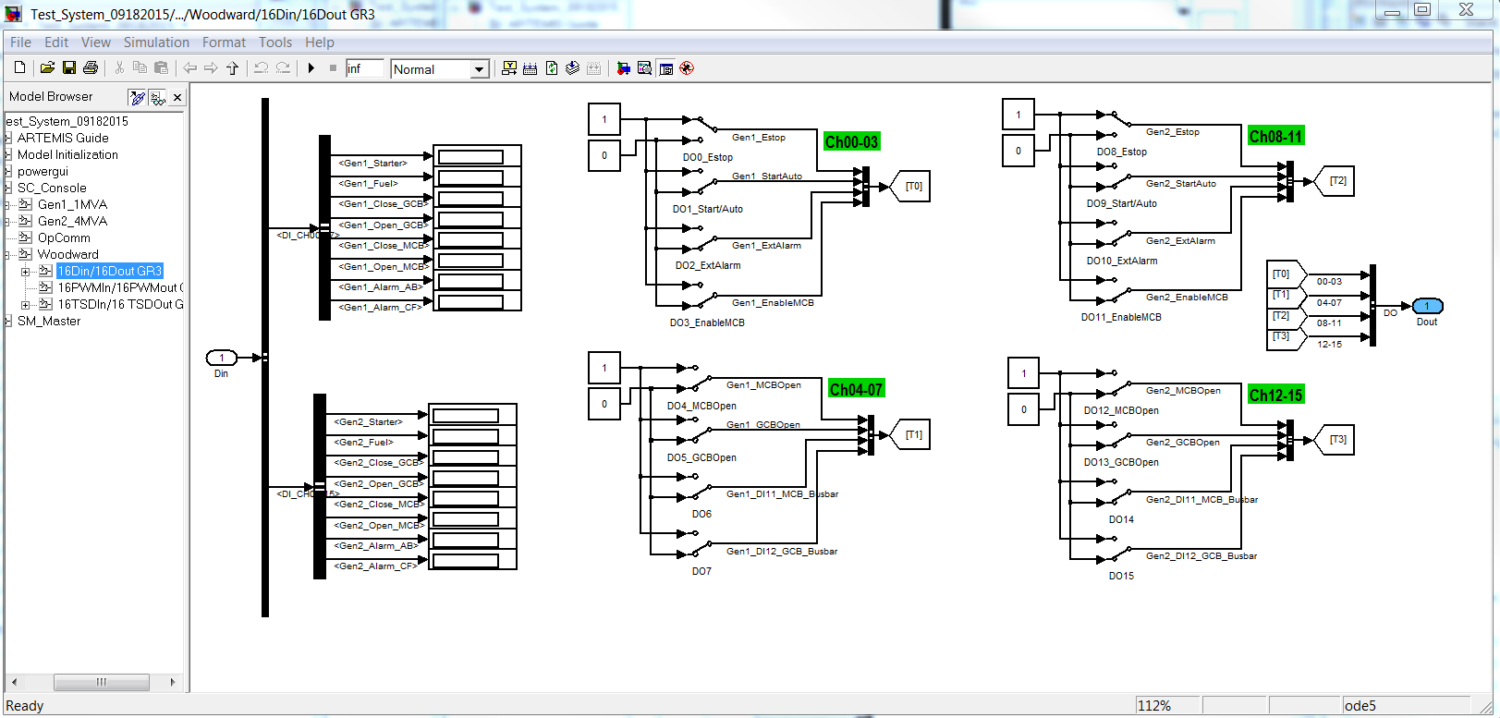

Figure 5: This is the testing interface for the digital inputs and outputs of the Woodward controller. It is not needed for the model to run as typically the microgrid controller would talk to the Woodward controller via Modbus communication.

##### 1.2.1.2 Simulated Secondary Controller (orange colored subsystem)

The real power (P in per unit), reactive power (Q in per unit), voltage (V in per unit), frequency (Hz in per unit), and enable generator (Startup = 1 and Shutdown = 0) are the control variables passed from the Console to the Master Subsystem.

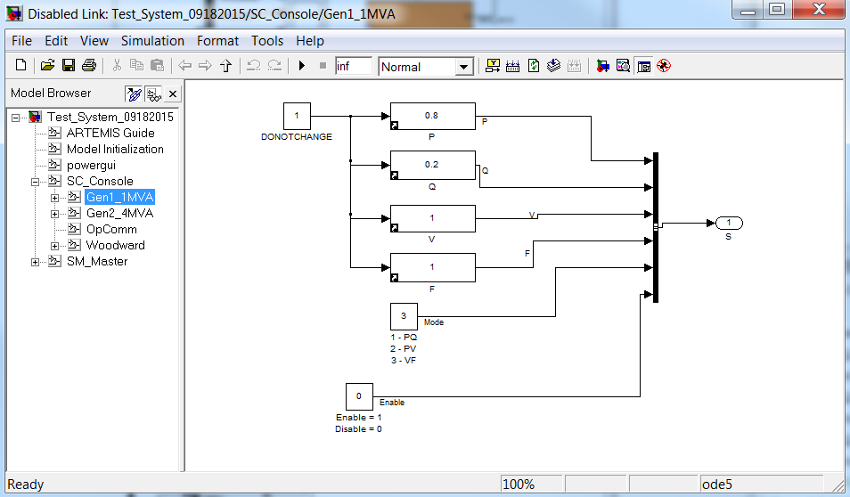

Figure 6: This the console model of the simulated generator secondary controller. This models control signals are different than the Woodward controller interface, therefore they are mapped to the appropriate primary controller interface.

### 1.2.2 Master Subsystem:

#### 1.2.2.1 Generator Model

This model includes the mapping of the Woodward output and input signals, generator primary and simulated secondary controllers, and any signal routing for control of generator and mains circuit breaker/relay. The blocks in white for the Woodward outputs and inputs will change depending on how your physical inputs and outputs are mapped to the virtual signals. The block in green can be replaced with other secondary, primary, and generator prime mover models.

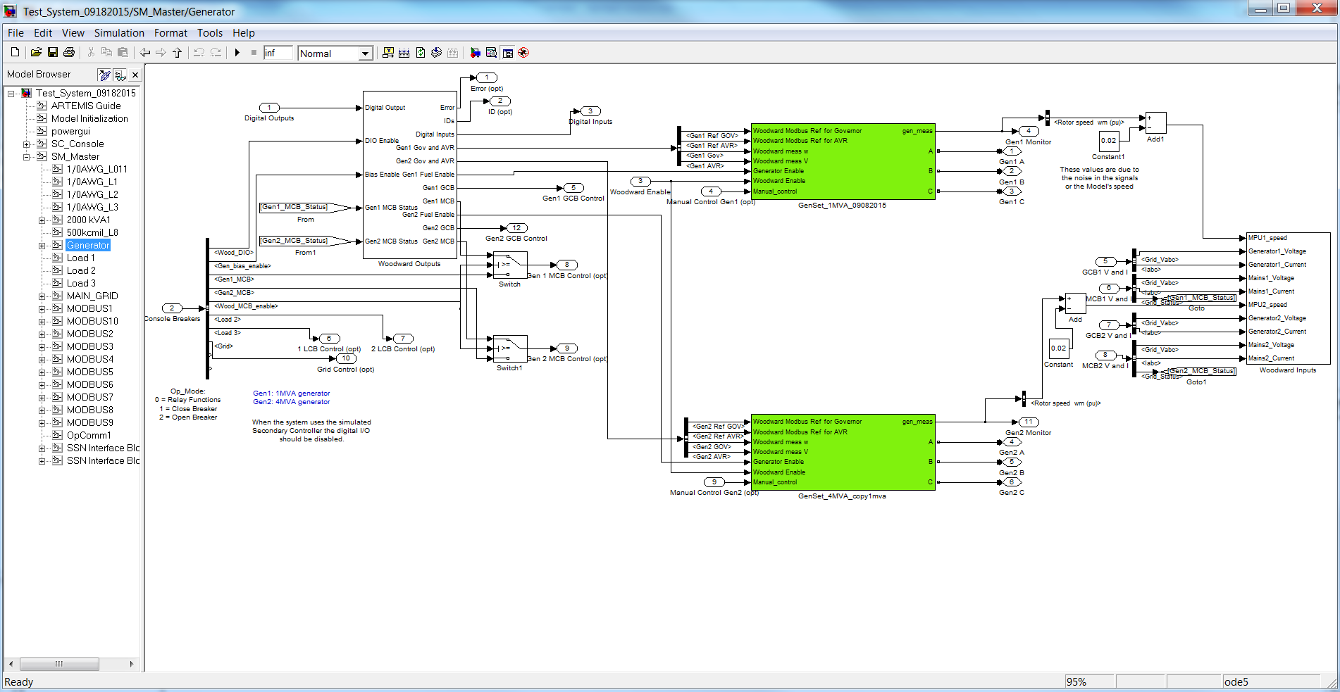

Figure 7: Generator interface model that includes the mapping of the Woodward secondary controller and the simulated secondary and primary generator controllers.

#### 1.2.2.1.1 Woodward Outputs

This subsystem shows the mapping of the physical Woodward outputs to the virtual signals. There is some logic inside the DIO-Woodward block that is used for the testing inputs in the console. They are not needed for normal operation of the model. The Woodward primary inputs have some signal conditioning to filter out the noise.

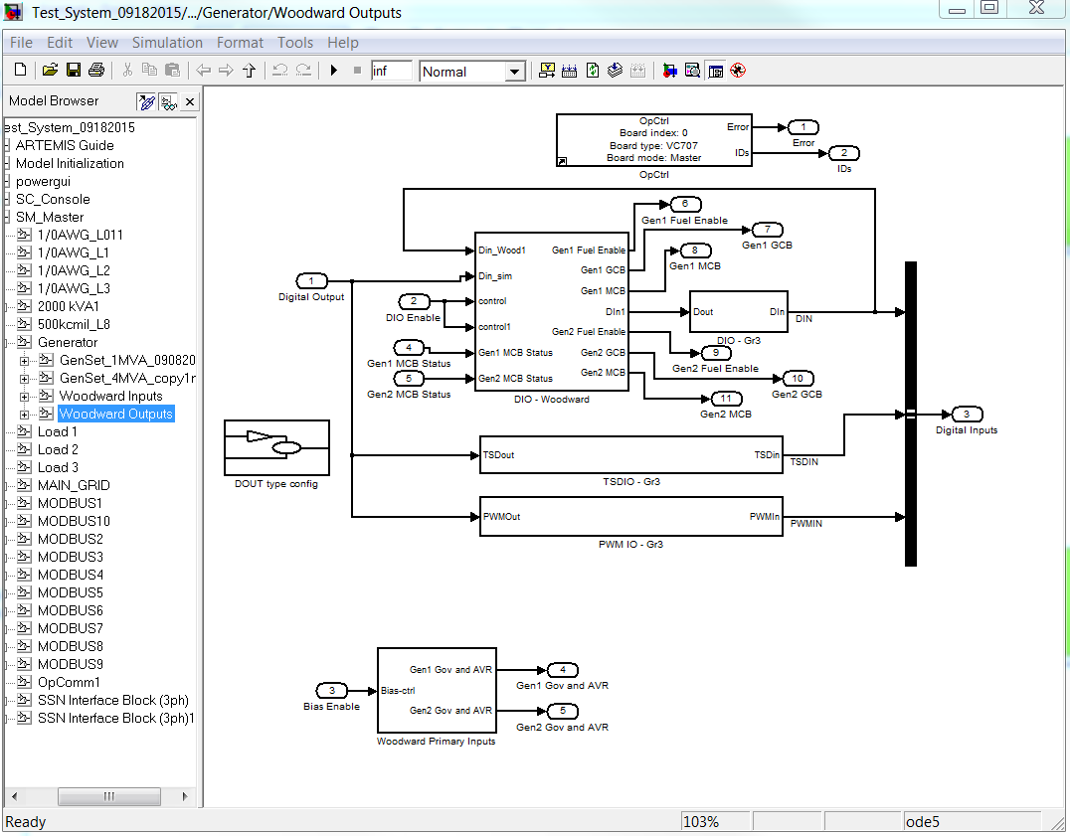

Figure 8: This subsystem is setup specific for the Woodward output mapping, testing logic, and signal conditioning.

#### 1.2.2.1.2 GenSet_xMVA (green colored subsytem)

This subsystem shows the simulated secondary controller (bottom left), primary controller (middle) that includes governor, automatic voltage regulator, and prime mover, and signal conditioning for numerical solutions (right). The models inside this system can be changed to more or less detailed components.

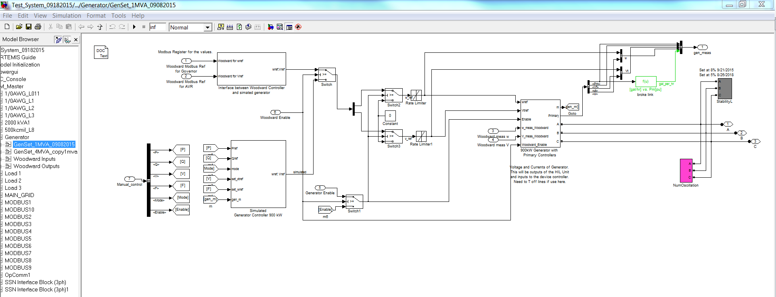

Figure 9: 1 MVA generator model of Woodward mapping, simulated secondary controller, and prime mover model.

#### 1.2.2.1.3 Woodward Inputs

This subsystem shows the mapping of the virtual signals to the physical Woodward inputs. Similar to the Woodward output subsystem, the mapping of these signals is setup specific.

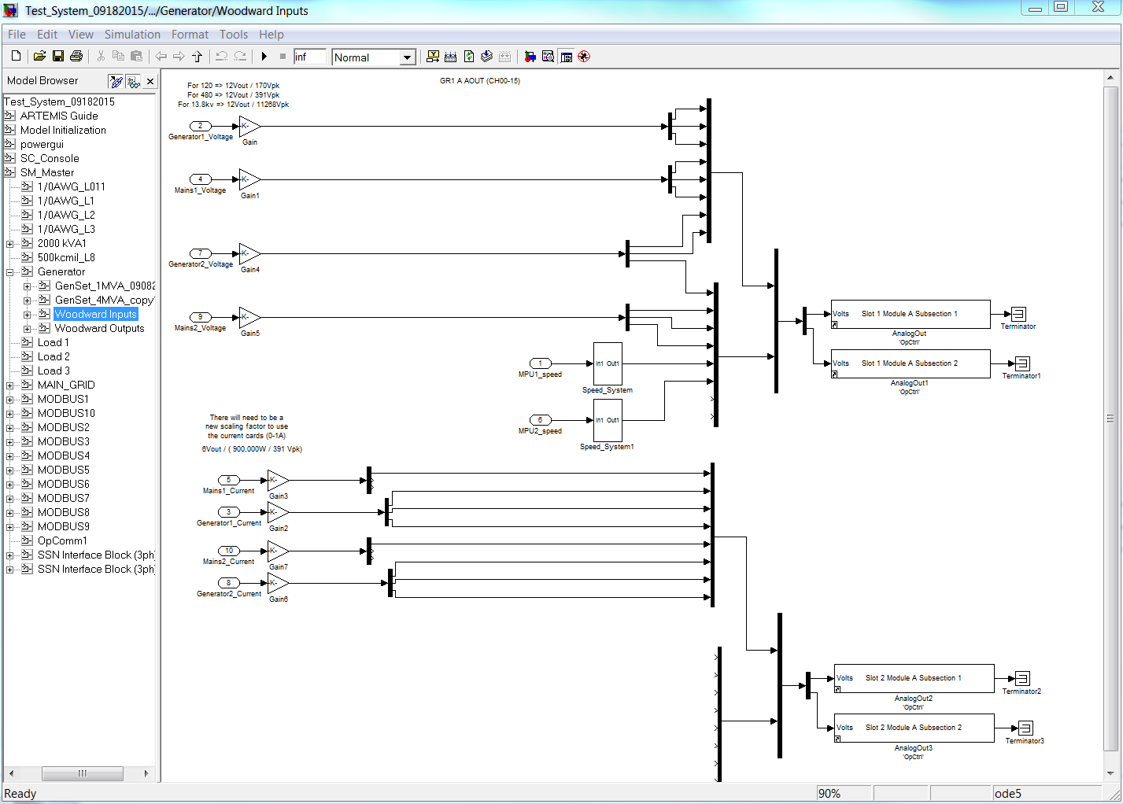

Figure 10: This is the mapping of the virtual signals to the Woodward inputs, and is specific to this particular setup.

## 1.3 Model Scope and Limitations

This modeled system is compatible with integration of a Woodward Easygen 3500 generator controller to the physically mapped input and output parameters in the model. If a different device controller or physical input and output ports are used, then modifications will be needed. The modeled system will function without a physical device controller, therefore the secondary controller would be simulated.

## 1.4 Examples:

### Milestone V9: 1 and 4 MVA Generators (Model run at the Symposium)

This demo shows grid tied and islanded operation of both the 1 and 4 MVA generators. There are three loads that can be changed in the system. When islanded the 4 MVA was operating in voltage and frequency (V F mode) and the 1 MVA followed in real power and power factor (P pf mode aka P Q mode). In addition, the previous version’s capabilities are still functional. Note: The last item to test on the physical device controllers is droop capability.

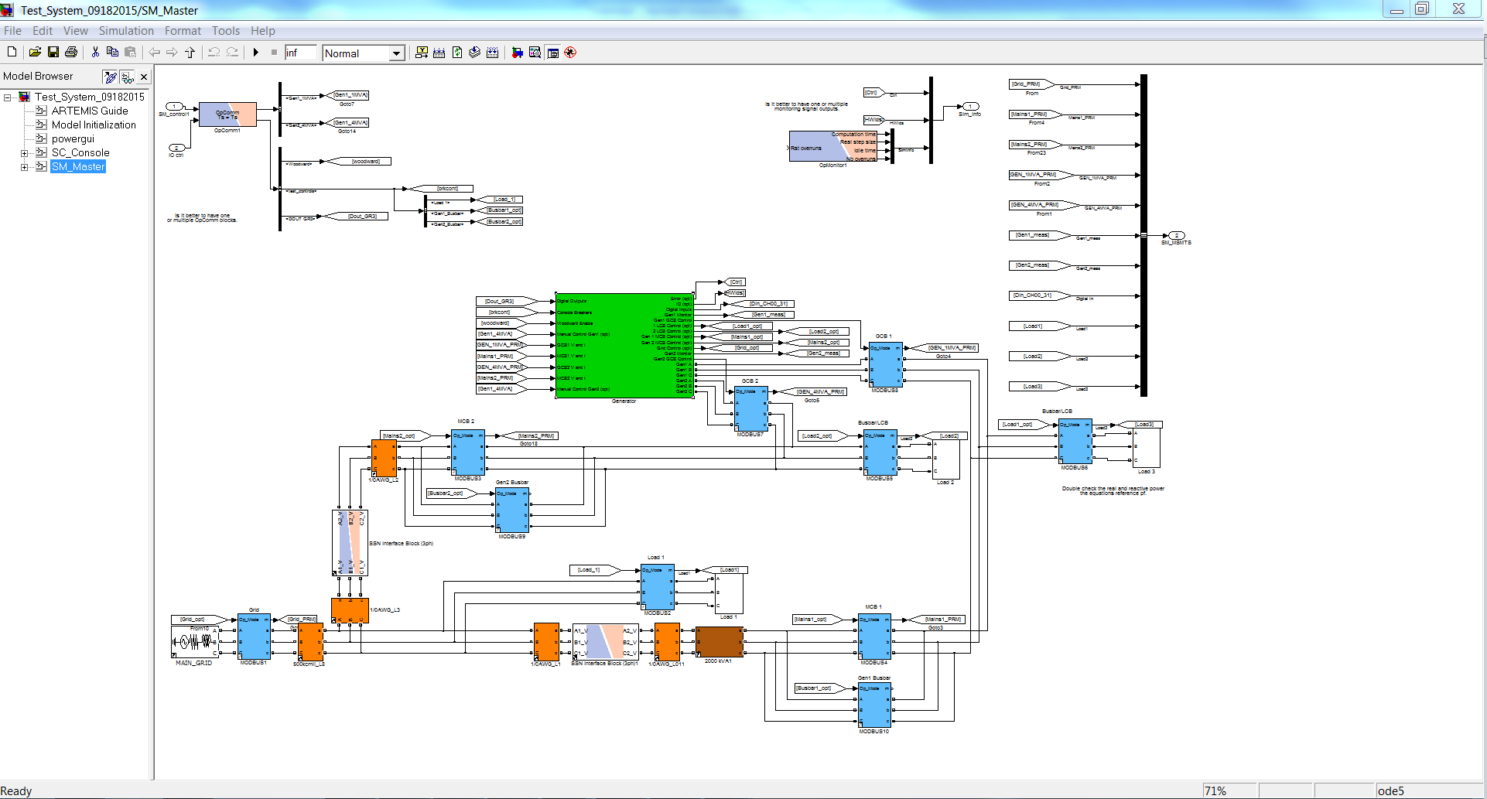

Figure 11: Milestone V9 model of Master Subsystem.

### Milestone V8: 1 MVA and 4 MVA Generators

This demo added the 1 and 4 MVA generators to the same “Generator” susbsystem (green square block). Each was tested to operate as a backup emergency generator, synchronize the GCB, synchronize the MCB, and perform stable operation when connected to the grid and changes in real power (P) and power factor (pf) were made. Data sheets on the generators’ values and ratings were compared to the models, and a low pass filter was added to the bias signals to reduce noise on the +-10 Vdc biases. The relay modules and Modbus blocks were updated using the library. The digital inputs and outputs of the 4 MVA were verified. In addition, the previous version’s capabilities are still functional. Note: The Modbus in the relay was removed to another core in the larger model to increase computation speed.

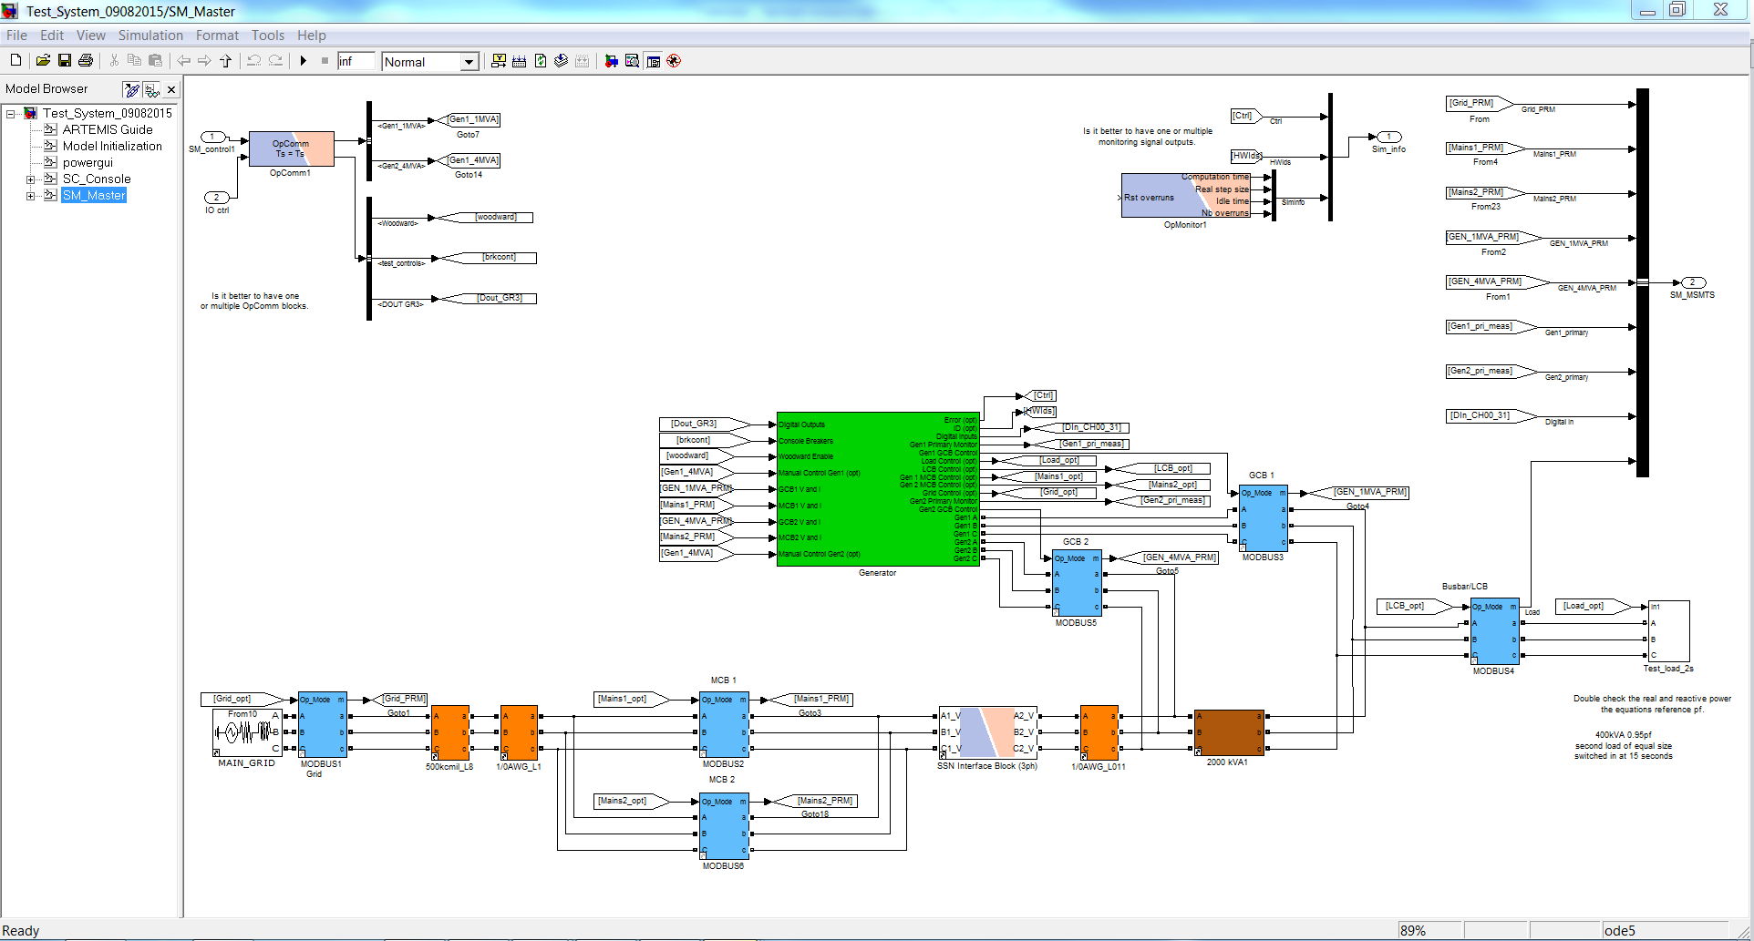

Figure 12: Milestone V8 model of Master Subsystem.

### Milestone V7: 900 kW Generator

This demo cleaned up the diagram and combined the mapping of the inputs and outputs inside the generator block model (green square block in the Master subsystem). The gains were changed for the voltages and currents because improved circuity components were added to the interface box and calibration of the components provided improved dynamic range of the signal conditioning. The currents for all 3 phases and the mains were configured for the correct outputs. The digital inputs and outputs were verified to work correctly. In addition, the previous version’s capabilities are still functional.

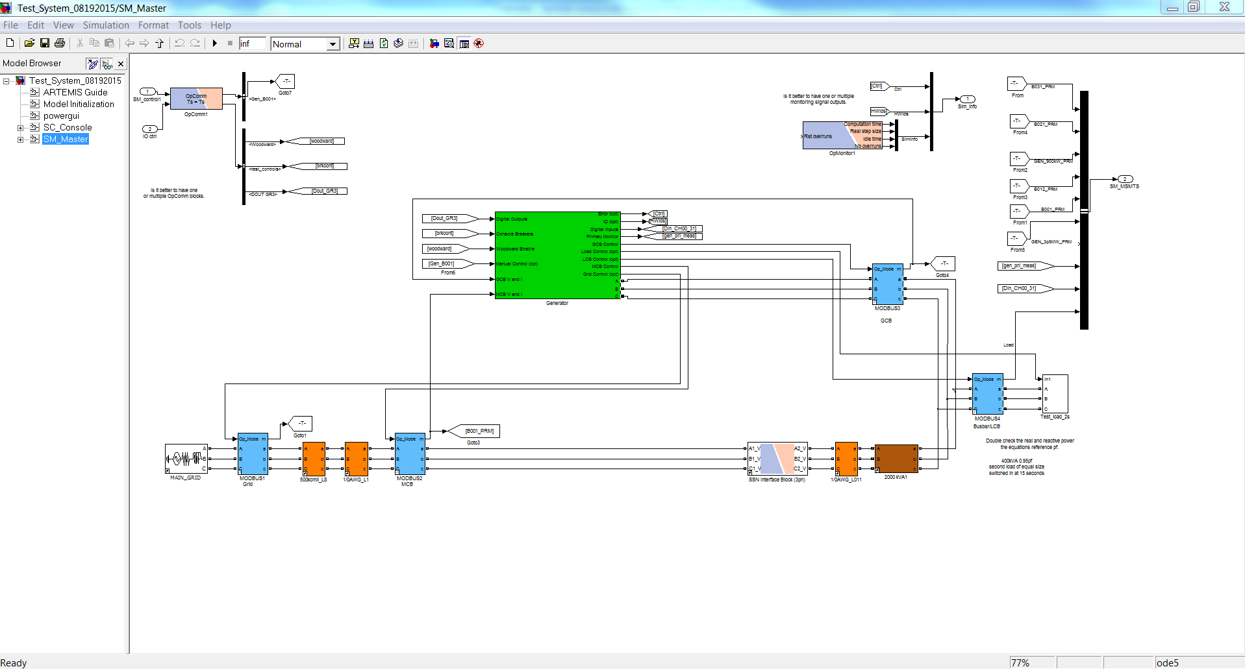

Figure 13: Milestone V7 model of Master Subsystem.

### Milestone V6: 900 kW Generator

This demo tested the physical device controller to synchronize to the grid and have stable operation when changing the physical controller’s power set points. In addition, the previous version’s capabilities are still functional.

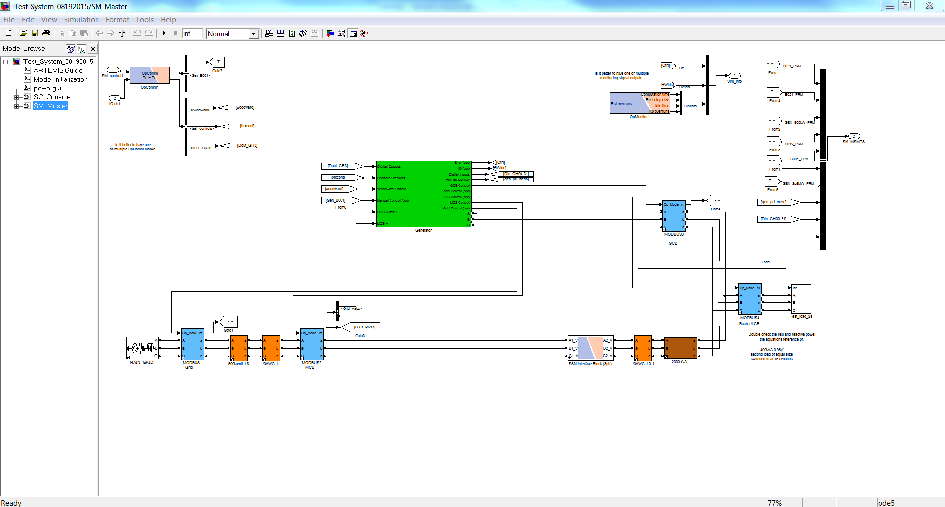

Figure 14: Milestone V6 model of Master Subsystem.

### Milestone V5: 900 kW Generator

This demo tested the physical device controller to be a backup emergency generator without synchronization to the grid.